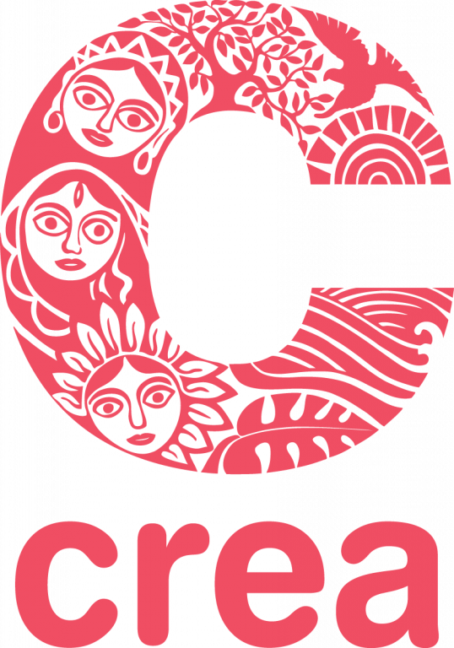
CREA’s 9th Disability, Sexuality, and Rights Online Institute
7 October –17 November, 2022
(Completely online, 6 weeks, 8-12 hours per week)

Applications by 5 August 2022.

CREA’s Disability, Sexuality, and Rights Online Institute (DSROI) is a six weeks long online course that provides a study of theory and practice at the intersection of disability, gender and sexuality with a focus on perspectives and experiences of persons with disabilities from the global South. Started in 2010, the Institute is, in majority, led by activists, community organizers and academics with disabilities from the global South. It is intended for activists from all human rights movements, practitioners, media and art specialists and donors.
The course is offered through an accessible online learning platform.
To apply, use the online application form: Application for CREA's 9th Disability, Sexuality, and Rights Online Institute. If you would like to complete the form manually visit this link to download the form and email it to Sushma Luthra at dsroi@creaworld.org. If you require accessibility accommodations in completing the application, please let us know at dsroi@creaworld.org. We also accept applications sent by video or through Zoom in Sign Language. Attach a copy of your latest resume or CV. All questions must be answered — your resume or CV cannot substitute for an answer.

About the Course
The DSROI focuses on a conceptual study of disability, gender and sexuality and its inter-linkages with feminism, sexual and gender diversity, race, sexual and reproductive health, gender-based violence, media, art, representation and law, amongst others. The DSROI has a strong focus on activists’ initiatives to address disability rights in practice from global South perspectives. The overall framing for disability rights is grounded in the Convention on the Rights of Persons with Disabilities (CRPD) and how these rights intersect across diverse constituencies. The Institute is aimed at activists, practitioners, and human rights actors working in areas such as disability rights, gender rights, development, sexual and reproductive health, sexuality, media, and law. The aim is to: create understanding on how disability, sexuality and gender intersect; build a political perspective on how the sexual rights of persons with disabilities can be upheld; strategize to combat ableism and provide knowledge on mechanisms and frameworks for building more inclusive and intersectional sexual rights advocacy. Participants develop their ability to work in inclusive and holistic ways that further human rights and social justice. After eight successful institutes, we now also have a wide-ranging alumni base spread across the globe.

Why take this course?
Here’s what our alumni had to say about it
- This course provided a great opportunity for me to systematically grasp knowledge and good practices about disability and sexuality. At different points it also prompted me to reflect on my personal experience as a woman with disability, and to use that as a resource of learning. – Zhying Ma, DSROI alumni 2016
- It has been a transformative experience for me — one where I now navigate the intersection of disability, sexuality and gender rights from a more nuanced perspective. I learnt so much from this experience and will carry forward many new strategies and ways to explore this intersection. – Joanna Marbaniang, DSROI alumni 2020
- The Institute had a big impact on my perspective as a gender and disability activist. Very timely, I was tasked to make a proposal for a regional policy document anchored on the CRPD. I remember a fellow participant in the Institute...I reached out to her with a hope that we could work together in the future and she quickly gave a positive response...we are [now] the first organization...to be working with LGBTQI group. – Gina Rose Balanlay, DSROI alumni 2020
- I loved the diverse resources, diverse topics, diverse methods of teaching and learning and especially the diversity of leaders with disabilities extending my knowledge and practice. Thank you for compiling such a great resource and for giving us a variety of ways to engage in it. - DSROI alumni 2021
- DSROI impacted me first personally, making room for liberation and self love and more body awareness. And professionally I feel more secure to support and discuss disability justice in the spaces where I work. - DSROI alumni 2021

- I really felt more strong and visible. It was more clear for me that I CAN work on what I stand for, to claim our rights. I think it has reminded me of the power of being in community and having spaces that are built by and for us from the sowing of seeds, rather than as an afterthought. - DSROI alumni 2021

Essential elements of the DSROI:
- The course will look at why sexual and disability rights matter looking at evolving theories of sexuality, disability and human rights
- We will center diversity of disability and sexuality representations and experiences across the globe
- We will learn from diverse activists, academics, and educators with disabilities how to advance the sexual rights and dismantle ableism
- We will discuss how to put rights into practice and in particular, those enshrined in the CRPD.
- We will examine efforts to end gender-based and ableist violence persons with disabilities face
- Faculty are persons with disabilities from across the globe working at the intersection of disability and sexuality
- We strive to create an accessible learning experience for diverse persons with disabilities and work with participants to provide the reasonable accommodations they need

The DSROI consists of live lectures and curated content (redings, videos, interviews). The institute allows for participants to work at their own pace downloading materials.This provides flexibility to manage the content on a timeframe that works best for you.

Format and Workload
The course will be conducted entirely online and in English. The online learning platform is fully accessible and lectures will be held using Zoom with live captioning in English and country specific Sign Language interpretation based on participant needs. There will be two live lectures each week which will be recorded and available online for participants unable to attend the live session. The course content will be available on the online learning platform for participants to review at their own pace each week. There will be live facilitated discussions and group exercises to allow for practical engagement in course content. The Institute will use diverse learning methods including: presentations, readings, videos (with subtitles), chats/ discussions, reading groups, practical exercises and video conferencing via Zoom. Participants will also be required to submit a final project. Although the course is introductory, the work will be challenging, including reading and discussion of complex theory. We encourage active engagement so participants can learn from each other’s thoughts and experiences.
Course participation will require between 8-12 hours per week. Each week’s requirements can be completed at the convenience of participants as long as it is within broader time parameters. Participants will be expected to participate in the entire course and complete all assignments, as much as possible.
Participants
The Disability, Sexuality, and Rights Institute is open to activists, practitioners, journalists, donors or philanthropists, legal experts, community-based organizers and development actors engaged in feminist advocacy, sexual and reprodutive health and rights, sexual and gender diversity, disability rights, development, media and arts worldwide.
Who can apply
Participants will be selected based on: demonstrated interest in disability and sexuality, and how the learning will apply to their work. Preference will be given to participants from the global South who work as activists and are connected to broader rights movements addressing sexual rights, disability and feminism; practitioners working on access to justice, sexual and reproductive health rights, gender-based violence; and donors or philanthropists with demonstrated commitment to supporting human rights. We strongly encourage persons with disabilities to apply!
Accessibility
The course has been designed and tested to be accessible to people with different types of disabilities. The online learning platform is accessible to those using screen reading software and all course materials are provided in accessible formats. All live lectures via video conferencing will have CART and country specific Sign Language interpretation upon request for selected participants. CREA staff are available to support additionally as needed.
Costs
Participants are required to pay a registration fee of USD 60 to contribute towards course expenses. Fee waiver is available on request for a very small percentage of participants on need basis (please refer to the application form).
Resource People
The Institute is designed and taught by an international group of academics and activists working at the intersections of disability, gender and sexuality with backgrounds on a range of issues including: sexual and reproductive health rights, sexual and gender-based violence, art and culture and social justice from a global South perspective.
Additional input from activists working on representation in art and culture, intersex rights, queer theory and disability, feminist disability organizing and more!
Organizer

CREA is a feminist human rights organization based in the global South, led by Southern feminists, working at the community, national, regional, and global levels. CREA builds feminist leadership, strengthens movements, expands sexual and reproductive freedoms, promotes rights-based approaches to reduce gender-based violence, and advances the human rights of structurally excluded people.

Applications will close on 5 August 2022. Applications received after this date will not be considered. Applicants will be informed about the selection decisions by September 10.

Contact Person: Sushma Luthra Email: dsroi@creaworld.org.

CREA
7 Mathura Road,
Jangpura B,
2nd Floor, New Delhi – 10014, India
Phone: 91-11-243-77707
Fax: 91-11-243-77708
Wesbite: www.creaworld.org

